Lab6 Exercise ITCSIU22266
Exercise 1:
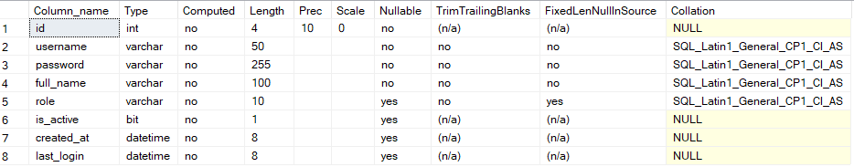
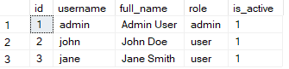
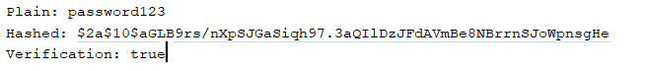

Excerise 2:
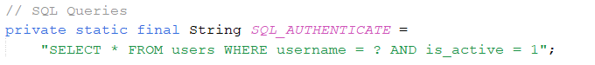
Check if that user is active or not
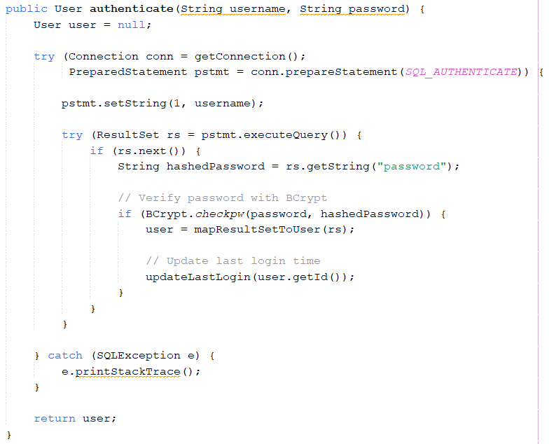
After checking if that user is active, check password. Password in database is hashed. The password input by user will be hashed and checked if it is the same as password in db of that user.
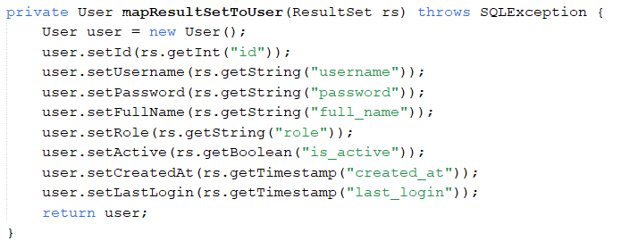
If yes, map the result with user id. And return user information. Then update the lastest login of that user.
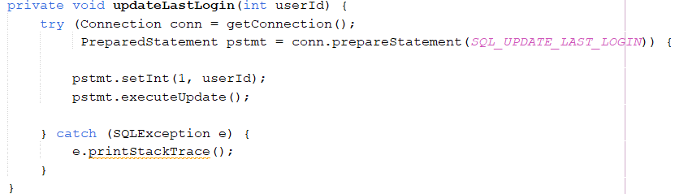
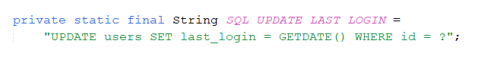
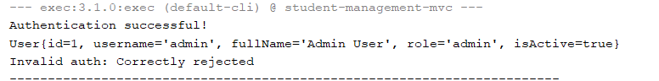
Exercise 3:
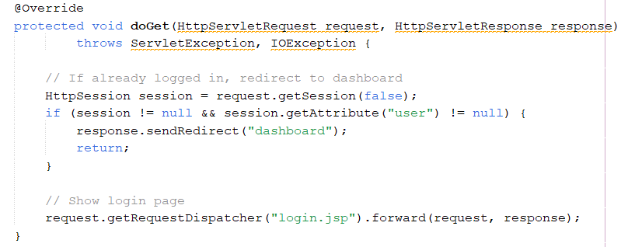
If user has already login with session still available, redirect to dashboard page.
Else, show login page.
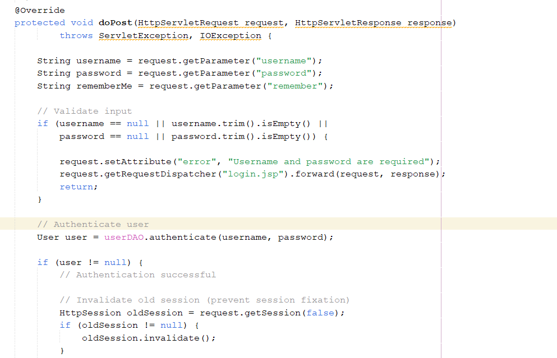
Get params from login page and validate the input.
Then call authenticate function with username and password.
If User is authenticated, clear the old session, and create new session.
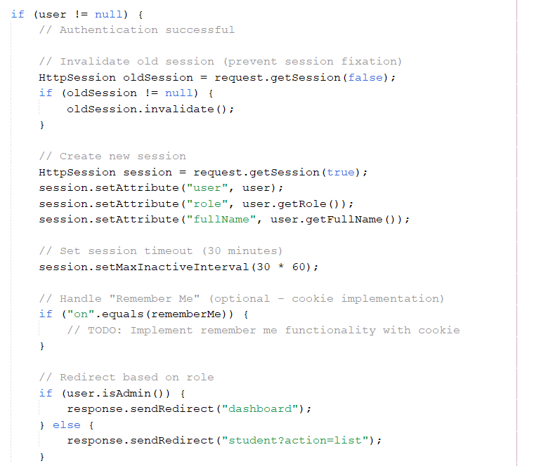
If User role is admin, redirect to admin dashboard, else, redirect to student page.
Else, show login page again with error message
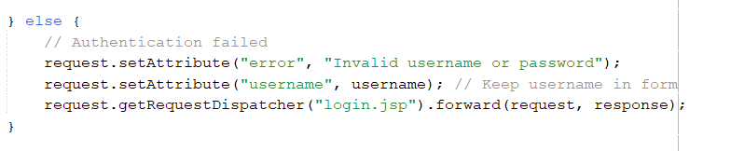
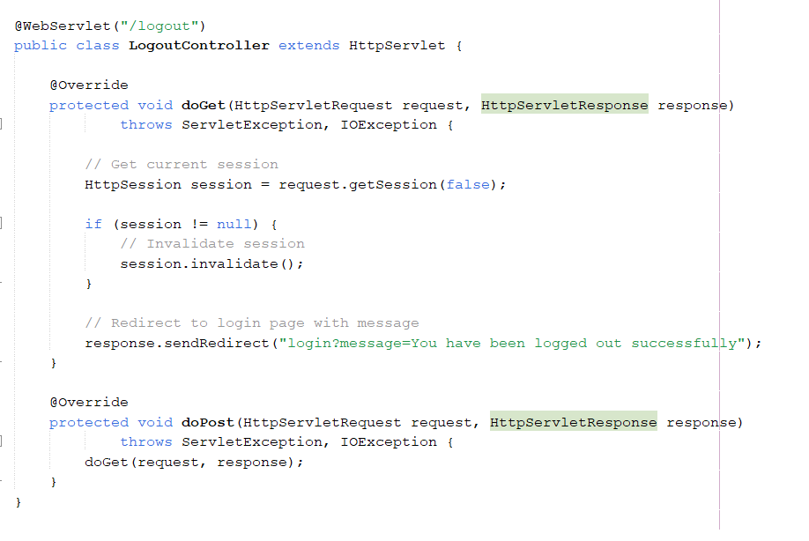
Login check the current session, then invalidate it, then redirect to login page.
Exercise 4:
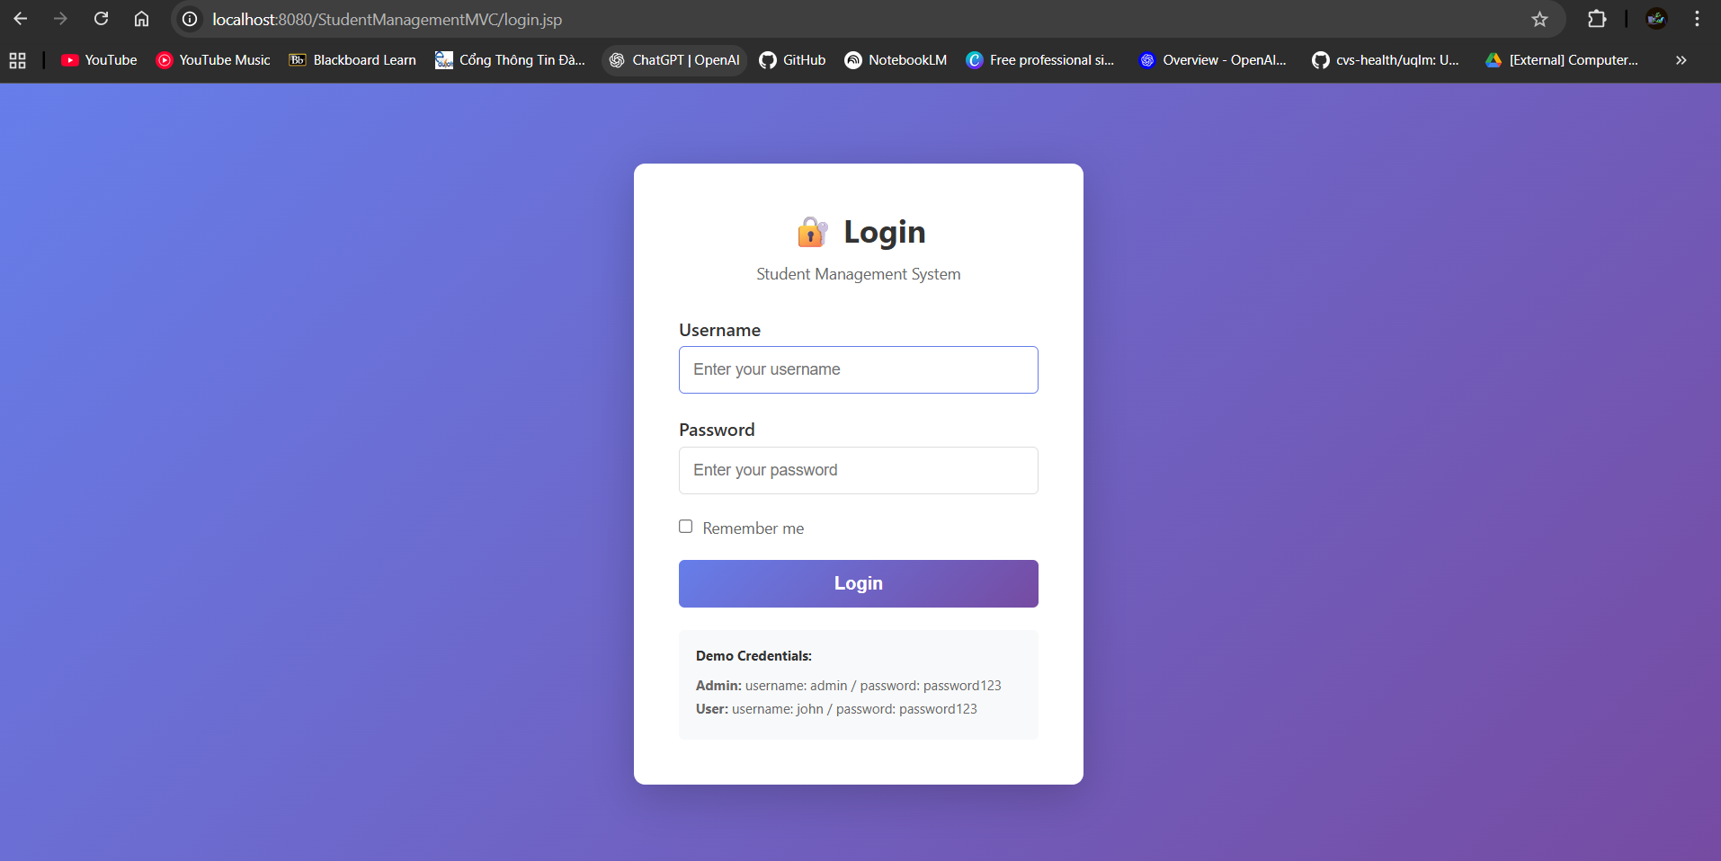
User fills input with username and password. Check remember me to save the cookie for next session.
If user role is admin, navigate to dashboard.jsp
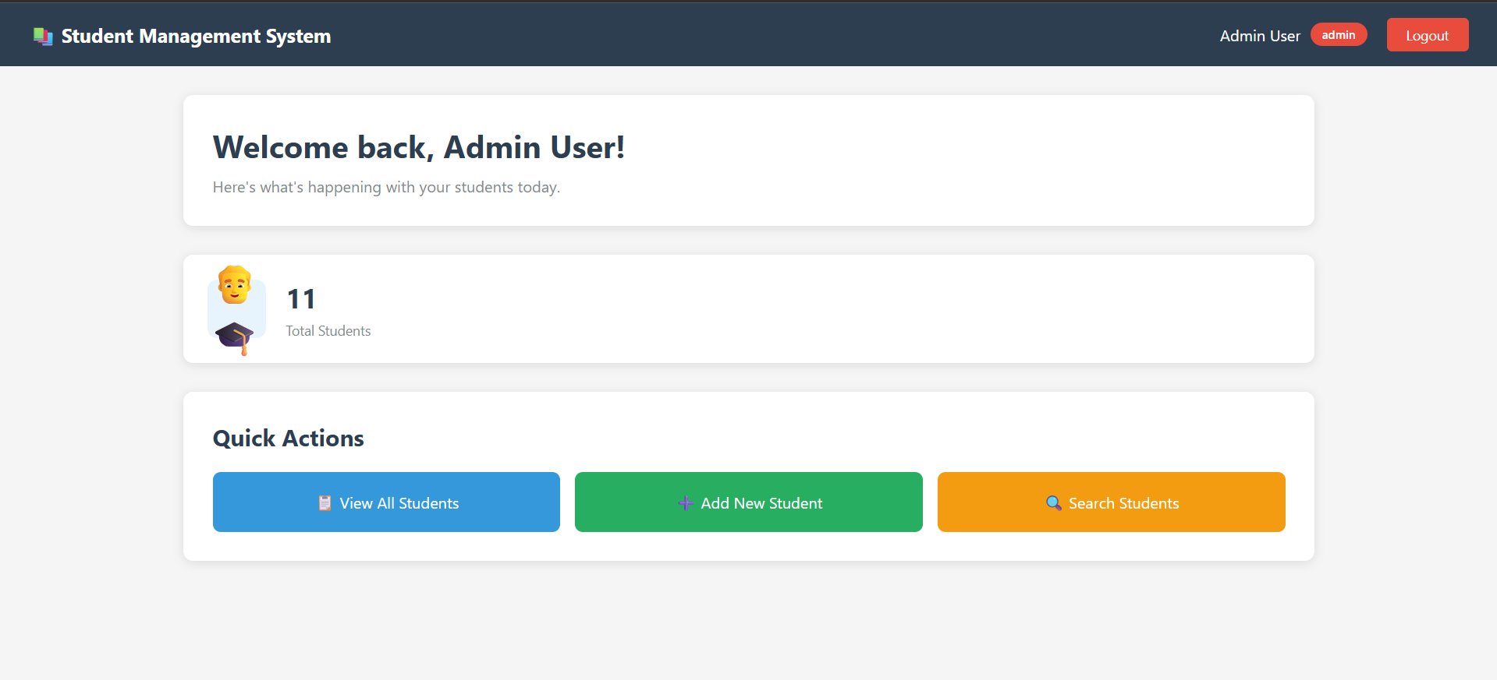
Dashboard get method check if the session is still available or not. If not, redirect to login page for a new session.
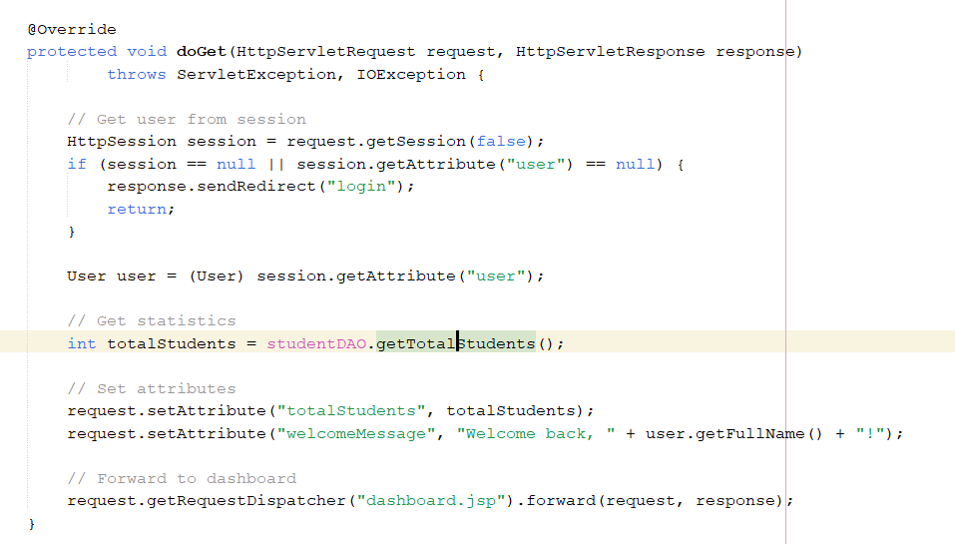

Else if user role is student, navigate to student page.
